**Project Design Phase-II**

**Technology Stack (Architecture & Stack)**

|  |  |
| --- | --- |
| Date | 27 June 2025 |
| Team ID | LTVIP2025TMID31916 |
| Project Name | HealthAI: Intelligent Healthcare Assistant Using IBM Granite |
| Maximum Marks | 4 Marks |

**Technical Architecture:**

The Deliverable shall include the architectural diagram as below and the information as per the table1 & table 2

**Example: Order processing during pandemics for offline mode**

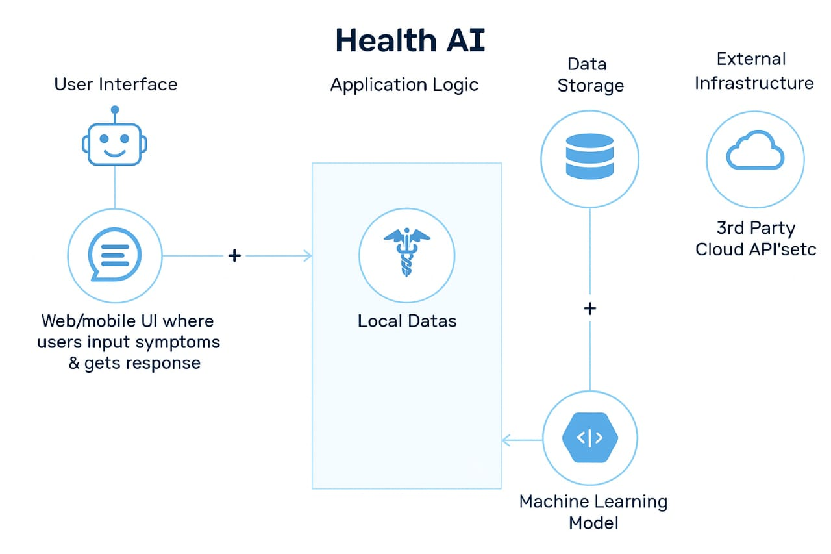

**Table-1 : Components & Technologies:**

|  |  |  |  |
| --- | --- | --- | --- |
| **S.No** | **Component** | **Description** | **Technology** |
|  | User Interface | Web/mobile UI where users input symptoms & get responses | HTML, CSS, ReactJS / Android, iOS, Chatbot (Dialogflow) |
|  | Application Logic-1 | Handles symptom input and user interaction | Java / Python |
|  | Application Logic-2 | Natural language processing of input | IBM Watson NLU / Google Dialogflow |
|  | Application Logic-3 | AI decision logic and risk prioritization | Python (Flask/Django), TensorFlow, Scikit-learn |
|  | Database | Stores patient data, medical records | MySQL / MongoDB |
|  | Cloud Database | Cloud storage for scale | IBM Cloudant / AWS RDS / Firebase |
|  | File Storage | Stores images (e.g., scans), reports | AWS S3 / IBM Block Storage |
|  | External API-1 | Pulls latest medical data / symptoms | WHO API, Healthline API |
|  | External API-2 | Aadhar or government integration for patient verification | Aadhar API / DigiLocker API |
|  | Machine Learning Model | Predicts condition based on symptoms and history | Symptom Checker Model (trained using medical datasets) |
|  | Infrastructure (Server / Cloud) | Deployment setup | IBM Cloud, AWS, Docker, Kubernetes, Local VMs |

**Table-2: Application Characteristics:**

| **S.NO** | **Characteristics** | **Description** | **Technology** |
| --- | --- | --- | --- |
|  | Open-Source Frameworks | Use of open-source libraries for ML, backened | TensorFlow, Scikit-learn, Flask |
|  | Security Implementations | Protects sensitive health data | SHA-256, OAuth 2.0, JWT, IAM, HIPAA Rules |
|  | Scalable Architecture | Supports thousands of users via microservices and cloud | Kubernetes, Docker, Cloud Foundry |
|  | Availability | Ensures uptime with distributed systems, load balancers | AWS Load Balancer, CDN, HAProxy |
|  | Performance | Uses caching and optimized ML inference to ensure low latency | Redis Cache, CDN, TensorRT |